Added support for a new domain and a new file type in the Test Case Generator chat."
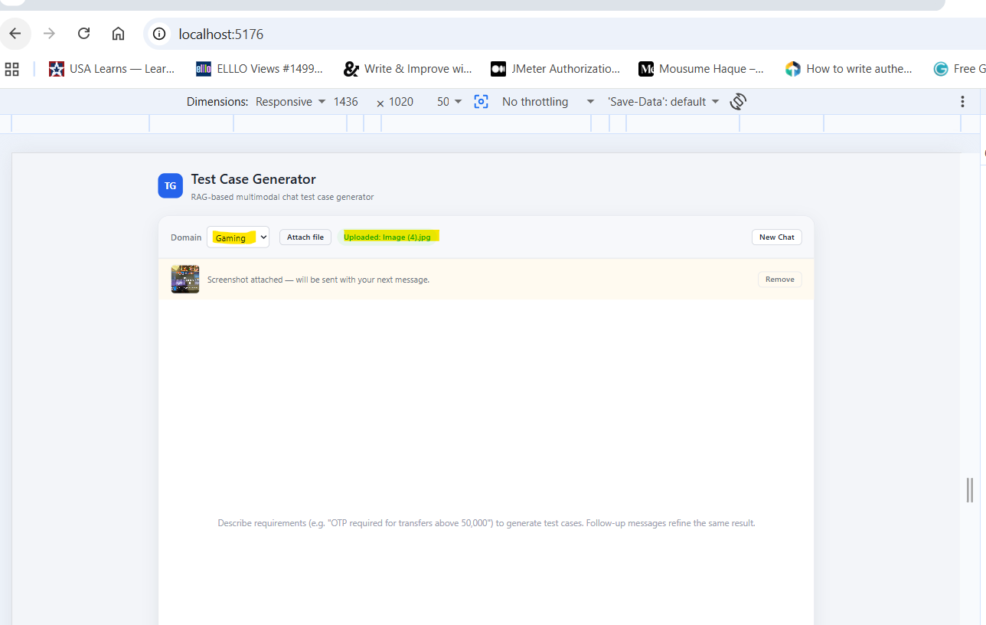

Enhanced the UI look and feel and introduced a Clear button to let users clear the chat window when they enter text by mistake.
